Name: Class:

Section 1
Task 1
Choose a website that you often use.
Record the URL of your chosen website here:
https://hsandbox.com
Paste a screenshot of one web page from the website below:
Consider the use of colour in the web page you have chosen. Record at least five positive features of the use of colour in the web page or negative uses of colour or areas for improvement.
Focus your answer on:
- The use of a limited range of colours
- The use of an organisational house style
- The use of colours that don’t clash
- The use of textures
- The use of the perception of colour (e.g., green for go/success, orange for warnings, red for stop/errors)
Positive uses of colour | Negative uses of colour or areas for improvement

Task 2
Work in a group of two or three. Your teacher will assign your group to one of the following options:
Group A: Font style/size, language and amount of information
Group B: Layout
Group C: User perception and retaining user attention
Group D: Intuitive design
- For each group, go to the section below with one or more screenshots of web pages (or part of a web page) you have found to illustrate each point.
- Write a brief explanation of how the web page has used each design principle.
- Once the class has finished,
Example:
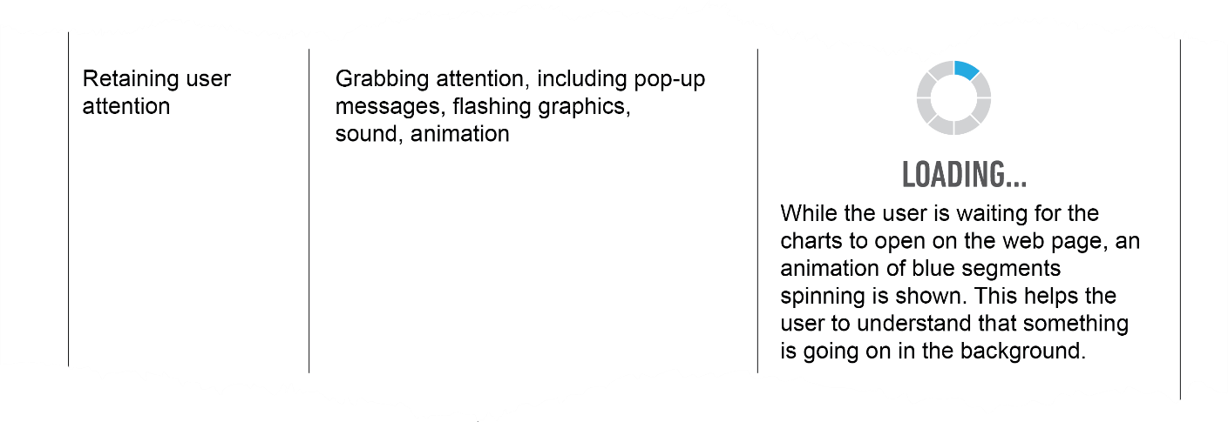

l

Group A
 | Design principles | Screenshots
Font style/size | Ensure text style/style is readable
Font style/size | Use of sans serif fonts for screen reading
Font style/size | Avoiding decorative fonts  (show where decorative fonts are and are not used)
Language | Using appropriate language for user needs, to include age-appropriate language
Language | Using language that is appropriate for user skill level
Amount of information | Providing appropriate amount of information for the task
Amount of information | Making appropriate use of white space

Group B
 | Design principles | Screenshots
Layout | Consistency throughout the whole interface
Layout | Keeping the layout as close as possible to user expectations
Layout | Placing important items in prominent positions
Layout | Grouping related tasks together
Layout | Use of navigational components to include search fields, breadcrumbs, icons
Layout | Use of input controls, to include dropdown lists, tick boxes, toggles

Group C
 | Design principles | Screenshots
User perception | User perception of sound (e.g., positive high-pitched sounds, negative low-pitched sounds)
User perception | Symbols (e.g., green ticks, red crosses)
User perception | Visuals (e.g., photographs, symbols, graphics)
Retaining user attention | Grabbing attention, including pop-up messages, flashing graphics, sound, animation  (Use a different example to the one shown as an example for this question)
Retaining user attention | Ensuring the screen is uncluttered
Retaining user attention | Clearly labelled items/features
Retaining user attention | Use of predetermined/default values for common user inputs
Retaining user attention | Use of autofill to reduce the amount of data entry needed, to include postcodes
Retaining user attention | Use of tip text to provide help if the user is unsure what buttons/tools do

Group D
 | Design principles | Screenshots
Intuitive design | Use graphics to denote what buttons do
Intuitive design | Helpful pop-up messages
Intuitive design | Easy-to-use help features
Intuitive design | Ensuring consistency
Intuitive design | Easy reversal of actions

Task 3
Look at the following screen design for the ‘Flavour’ screen.

Cola Bottles

Shake & Sweets
Flavour

+
Make this screen using either PowerPoint or software that your teacher recommends.

Your final implementation should have the following features:
- Title in an attractive font
- An actual image of Cola Bottles
- A magnifying glass (this can be made with a +, circle and line)
- When the magnifying glass is pressed, the image appears full screen
- When the full screen image is pressed, the image goes back to normal size
- A full description of the flavour is given using a sans-serif font
- When the home button is pressed, a new blank screen is displayed

The colour scheme for the project is as follows:
#DD2E25 | #E9A81F | #74B84C | #000000
Title colour  Home icon | Background | Sub-title colour | Text colour  Magnifying glass  Menu icon

To alter the hex colour in PowerPoint use:
Fill > More colours… > Custom > Hex

Section 2
Adventure Aquarium
You have been asked to design an interactive information kiosk for Adventure Aquarium.
The kiosks will be:
- Located at various places around the aquarium
- The kiosks require the following four screens:
  - a home screen with map
  - a screen about the different marine life at the aquarium
  - a screen showing facilities
  - a screen showing opening times.
Task 1
When completing this task, refer back to the storyboard that you made for the Adventure Aquarium information kiosk in the last topic.
(a) Create at least two screens for the touch screen information kiosk. The following features should be included:
- Makes use of design principles, in particular, layout, whitespace and consistency
- Uses navigation methods
- Accurately references the project brief
- Considers the user experience and accessible needs
You should complete your information kiosk designs using either PowerPoint or the software that your teacher suggests.
(b) Take a screenshot of each screen you have created and paste it into your ‘Adventure Aquarium’ document.
(c) Add annotations around each screenshot to show where all the features are being used and justify why you have used each feature.

